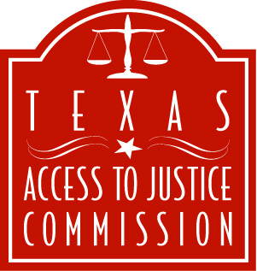

For Immediate Release
February 6, 2006

Contact: Laura Figueroa
lfigueroa@teajf.org
512.320.0099, ext. 104
512.659.4750 (mobile)

TEXAS ACCESS TO JUSTICE COMMISSION HONORS REPRESENTATIVE
SYLVESTER TURNER OF HOUSTON FOR HIS SUPPORT OF LEGAL AID

AUSTIN, Texas – Texas Supreme Court Justice Harriet O’Neill, on behalf of the Texas Access to Justice Commission, presented Texas State Representative Sylvester Turner, D-Houston, with the “Star of Justice Award” for his long-standing efforts to increase state funding for legal aid.

At the award presentation, held during the Houston Bar Foundation Annual Luncheon, O’Neill praised Turner for supporting efforts to increase access to the justice system for indigent Texans.

“Representative Turner’s hard work in the Legislature to secure much-needed funding for legal aid will ensure that more low-income Texans living on the edge will be able to access our legal system to secure protection from domestic violence, assistance for the elderly and disabled, and help for those displaced by the recent hurricanes,” O’Neill said. “The Commission and the Supreme Court are very grateful for his help.”

Legal aid organizations help more than 99,000 low-income Texans each year with their civil legal needs. However, for every one person helped by legal aid, a qualifying individual is turned away; there are simply not enough resources to help everyone who needs the service. Turner has played an instrumental role in securing additional funding for legal aid, including revenue from fees assessed to out-of-state lawyers practicing in Texas and a $3 million general appropriation for the next biennium ($1.5 million per year).

“Ensuring equality in our justice system is vital to the principles that Texas stands for,” Turner said. “It is society's burden to guarantee justice for all, not just for those who can afford it. It is an honor to receive this award from the Texas Access to Justice Commission, and I look forward to helping make the promise of justice a reality.”

Legal aid provides free advice or representation in matters such as housing, protection from domestic violence and consumer issues. In Harris County, 15 percent of the population lives in poverty. To qualify for legal aid, an individual must earn less than $12,250 per year.

The Texas Access to Justice Commission (www.texasatj.org) was created by the Supreme Court of Texas to coordinate legal aid services for poor Texans. The Commission is charged with increasing resources for legal aid and developing policy initiatives to increase access to the legal system for Texas’ most vulnerable residents.

-30-

