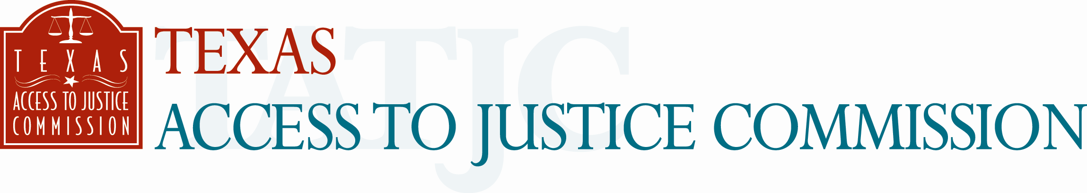

FOR IMMEDIATE RELEASE
April 12, 2005

Contact: Laura Figueroa
512.659.4750 (mobile)
512.320.0099, ext.104 (office)

SELF-HELP PROTECTIVE ORDER KIT NOW AVAILABLE FOR

DOMESTIC VIOLENCE VICTIMS
Supreme Court of Texas and Texas Access to Justice Commission collaborate to provide low-income victims access to court-ordered protection.

Austin, Texas --- The Supreme Court of Texas, in collaboration with the Texas Access to Justice Commission, today unveiled a self-help Protective Order Kit which will enable victims of domestic violence to file their own applications for protective order. The kit, created by a Texas Supreme Court Task Force, will make it possible for victims to have access to court-ordered protection for themselves and their children, including compelling the abuser to leave the home if necessary.

The Protective Order Kit was unveiled at a press conference to commemorate National Crime Victims’ Rights Awareness Week, which is observed April 10-16, 2005. Texas First Lady Anita Perry, Texas Attorney General Greg Abbott and Supreme Court Justice Harriet O’Neill spoke at the press conference in support of the Protective Order Kit. Additionally, Thomasina Olaniyi-Oke, a survivor of domestic violence, spoke about how legal aid helped her escape a violent marriage.

The free, step-by-step Protective Order Kit comes with detailed instructions for filling out the paperwork, having a temporary order signed by a judge and requesting a hearing date to grant the protective order. The temporary order and the protective order are enforceable once they are signed by a judge. The kit also provides helpful information for victims on how to prepare for the hearing. There is no cost to the victims to participate in these proceedings.

The Protective Order Kit is available at www.TexasLawHelp.org. The kit will be translated into Spanish and Vietnamese within six months.

At the press conference, Perry and Abbott praised the Supreme Court for its vision in authorizing the development of a packet that at the least may give victims peace of mind, and at most may save lives.

“Domestic violence is a tragedy that affects far too many families in our state,” Perry said. “The Protective Order Kit will give families and individuals the opportunity to begin on the path to the life everybody deserves – one free of fear and full of hope – back on the road to happiness.”

In 2003, more than 185,000 domestic violence incidents were reported in Texas. In the same year, 153 women were murdered by an intimate partner. The availability of the Protective Order Kit will be especially helpful to women who cannot afford to hire an attorney. The Protective Order Kit may be their only alternative, if they do not qualify for free legal assistance.

“Domestic violence has reached alarming levels in Texas, and often victims are too frightened or too financially strapped to get the help they need," Abbott said. "This kit addresses both of those problems by empowering victims to file their own court papers and get out of danger as quickly as possible.”

The Protective Order Task Force, which developed the kit, is composed of experienced family law practitioners, judges and prosecutors from throughout Texas. The Texas Access to Justice Commission, with a $26,000 grant from the Texas Bar Foundation, will distribute the kit in hard copy and on CD to law enforcement agencies (including police departments and sheriff offices), domestic violence shelters, medical facilities, court clerks and public libraries. Since its inception in 1965, the Texas Bar Foundation has awarded more than $6 million in grants to law-related programs. Supported by members of the State Bar of Texas, the Texas Bar Foundation is the nation's largest charitably-funded bar foundation.

Time Warner Cable and KWEX-TV Univision in San Antonio donated production services for the development of English- and Spanish-language public service announcements, which will be aired statewide to publicize the kit.

“Though there is no substitute for legal representation for victims of domestic violence, the Protective Order Kit can be an invaluable tool for those who do not have access to a lawyer,” Texas Supreme Court Justice Harriet O’Neill said. “We want to let family violence victims, particularly those of limited means, know that there is a way out.”

The Protective Order Kit can be downloaded at www.TexasLawHelp.org. Individuals needing assistance with filling out the paperwork, information about their legal rights or assistance with safety planning should call the Women’s Advocacy Project’s Family Violence Legal Line at 800.374.4673.

-30-

