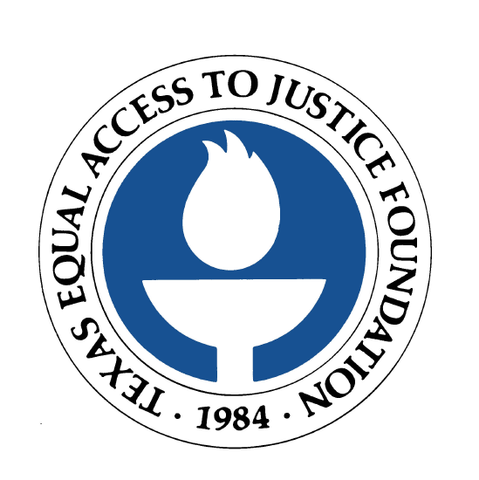

FOR IMMEDIATE RELEASE
October 19, 2005

Contact: Laura Figueroa
512.320.0099 x.104 (office)
512.659.4750 (mobile)

EXXONMOBIL DONATES $50,000 TO TEXAS EQUAL ACCESS TO JUSTICE FOUNDATION’S KATRINA LEGAL AID FUND
Funds will be used to assist hurricane victims with civil legal issues

AUSTIN, Texas  ExxonMobil has donated $50,000 to the Texas Equal Access to Justice Foundation’s Katrina Legal Aid Fund. The Fund was created initially to support legal aid offices providing legal services to victims of Hurricane Katrina who are residing in Texas. The fund has been expanded to include victims of Hurricane Rita.

The Texas Equal Access to Justice Foundation, the largest state-based funder of legal aid in Texas, recently made available $1 million in emergency funding for legal aid organizations working with victims of Hurricane Katrina and now Rita. These individuals face daunting legal issues, including insurance claims, FEMA benefits, housing, employment issues and much more. Legal matters affecting disaster victims can last months or even years.

ExxonMobil General Counsel Charles Matthews said that the corporation and its employees have supported legal aid for many years and are responding to the increased pressure on legal aid organizations as a result of the hurricanes.

“Legal aid is an often overlooked community need,” Matthews, who also chairs the Texas Access to Justice Commission’s Corporate Counsel Committee, said. “We strive to recognize and respond to this need through our volunteer efforts and financial support.”

The Texas Equal Access to Justice Foundation, at its annual luncheon with the Supreme Court of Texas, presented ExxonMobil with the “Access to Justice” award in recognition of the corporation’s generosity.

Foundation Executive Director Betty Balli Torres said, “The Foundation is very pleased to receive such a generous donation from ExxonMobil. Through this donation, the corporation is giving hope to those who have suffered through a terrible tragedy.”

Donations to the Katrina Legal Aid Fund may be made at www.teajf.org, or by calling 512.320.0099.

The Texas Equal Access to Justice Foundation (www.teajf.org), created by the Supreme Court of Texas in 1984, is the largest state-based funding source for the provision of civil legal aid in Texas. The organization is committed to the vision that all Texans will have equal access to justice, regardless of their income. The Foundation administers a variety of funding sources, which are earmarked to assist nonprofit organizations in providing legal aid to approximately 99,000 Texans each year.

###

