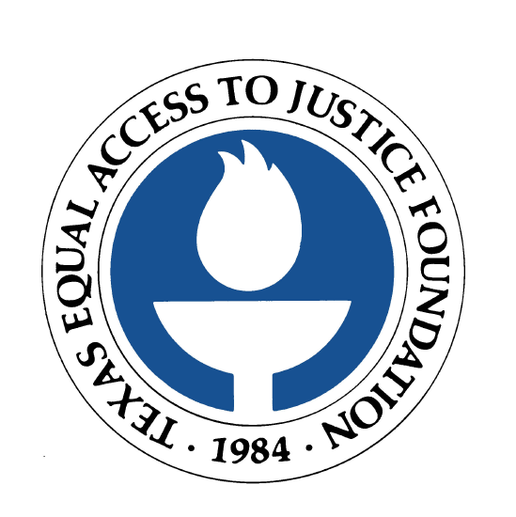

FOR IMMEDIATE RELEASE
February 9, 2006

Contact: Laura Figueroa
512.320.0099 x.104 (office)
512.659.4750 (mobile)

CONOCOPHILLIPS DONATES $50,000 TO TEXAS EQUAL ACCESS TO JUSTICE FOUNDATION’S KATRINA LEGAL AID FUND
Funds will be used to assist hurricane victims with civil legal issues

AUSTIN, Texas  Houston-based ConocoPhillips has donated $50,000 to the Texas Equal Access to Justice Foundation’s Katrina Legal Aid Fund. The Fund supports legal aid offices providing legal services to victims of Hurricanes Katrina and Rita.

Disaster victims face daunting legal challenges, including accessing FEMA benefits, addressing housing problems, and dealing with employment issues. Legal matters affecting disaster victims can last months or even years. The Texas Equal Access to Justice Foundation, the largest state-based funder of legal aid in Texas, has made available $1 million in emergency funding for legal aid organizations working with victims of Hurricanes Katrina and Rita.

Stephen F. Gates, ConocoPhillips senior vice president and general counsel, said “Our company is pleased to contribute to this fund to help address the increased demand for legal services to the disadvantaged as a result of Hurricanes Katrina and Rita.”

As of January, Texas legal aid organizations had closed almost 7,200 hurricane-related cases. More than 1,300 remain open, and more are expected to surface over the next several months.

Betty Balli Torres, executive director of the Texas Equal Access to Justice Foundation, said, “The hurricanes have exacerbated what was already a dire financial situation for legal aid organizations. Contributions, such as the generous donation from ConocoPhillips, are vital to ensure that more low-income Texans and victims of the two disasters receive the legal services they so desperately need.”

The Texas Equal Access to Justice Foundation presented ConocoPhillips with the “Access to Justice” award at the Houston Bar Foundation Annual Luncheon in recognition of the corporation’s support of access to justice for Texas’ poor.

Donations to the Katrina Legal Aid Fund may be made at www.teajf.org, or by calling 512.320.0099.

The Texas Equal Access to Justice Foundation (www.teajf.org), created by the Supreme Court of Texas in 1984, is the largest state-based funding source for the provision of civil legal aid in Texas. The organization is committed to the vision that all Texans will have equal access to justice, regardless of their income. The Foundation administers a variety of funding sources, which are earmarked to assist nonprofit organizations in providing legal aid to approximately 99,000 Texans each year.

###

