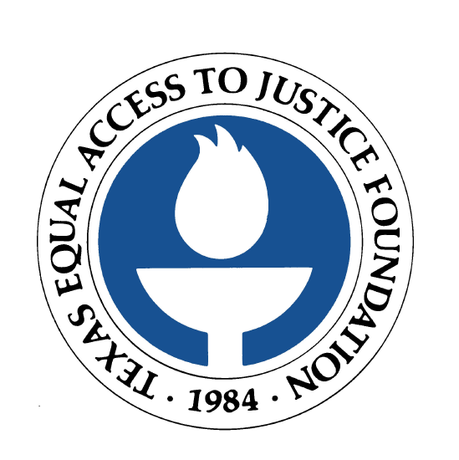

FOR IMMEDIATE RELEASE
October 19, 2005

Contact: Laura Figueroa
512.320.0099 x.104 (office)
512.659.4750 (mobile)

NATIONAL STUDY REVEALS FIFTY PERCENT OF POOR AMERICANS
DO NOT HAVE ACCESS TO LEGAL AID
Texas Equal Access to Justice Foundation says figure consistent with Texas legal aid

AUSTIN, Texas  A study just released by the Legal Services Corporation reveals that 50 percent of indigent Americans who need and qualify for civil legal aid do not receive services, because legal aid offices do not have the resources to help them. The figure is consistent with informal findings in Texas.

The study’s results do not include low-income individuals who have legal problems but do not know about the availability of legal aid. The study was completed prior to Hurricanes Katrina and Rita; therefore, it also does not include displaced residents of hurricane-affected areas.

The Texas Equal Access to Justice Foundation, the largest state-based funder of legal aid organizations in Texas, has undertaken long-term efforts to diversify and increase funding; however, much more is needed to minimize the number of eligible Texans who are turned away from legal aid each year. Texas currently ranks 40th in the nation in terms of funding for legal aid.

Betty Balli Torres, executive director of the Texas Equal Access to Justice Foundation, says it takes about $60 million to provide legal aid to 100,000 people. There are 3.7 million poor people living in Texas.

“Legal aid staff and volunteers work tirelessly on behalf of our state’s most vulnerable residents, including children, the elderly and the disabled,” Balli Torres said. “But we need significantly more resources to ensure justice for more people. When we empower individuals and families, we strengthen the entire community.”

Legal aid organizations provide advice or representation at no cost to Texans living at or below 125 percent of the federal poverty level. To qualify for legal aid, an individual cannot earn more than $11, 963 per year. Common civil legal issues include protection from domestic violence, housing and public benefits. The three primary providers of legal aid in Texas are Nacogdoches-based Lone Star Legal Aid, which serves East Texas; Arlington-based Legal Aid of NorthWest Texas, which serves the northern part of the state; and Weslaco-based Texas RioGrande Legal Aid, which serves Central, South and West Texas. Every county in Texas is served by one of the three organizations.

The Texas Equal Access to Justice Foundation encourages low-income Texans with legal questions to visit www.TexasLawHelp.org, a Web site dedicated to providing free, reliable legal information to those who cannot afford legal help. The Web site was developed by the Texas legal aid community as a means to utilize technology and the Internet to serve more people in need.

To view the Legal Services Corporation study, visit www.lsc.gov.

The Texas Equal Access to Justice Foundation (www.teajf.org), created by the Supreme Court of Texas in 1984, is the largest state-based funding source for the provision of civil legal aid in Texas. The organization is committed to the vision that all Texans will have equal access to justice, regardless of their income. The Foundation administers a variety of funding sources, which are earmarked to assist nonprofit organizations in providing legal aid to approximately 99,000 Texans each year.

###

