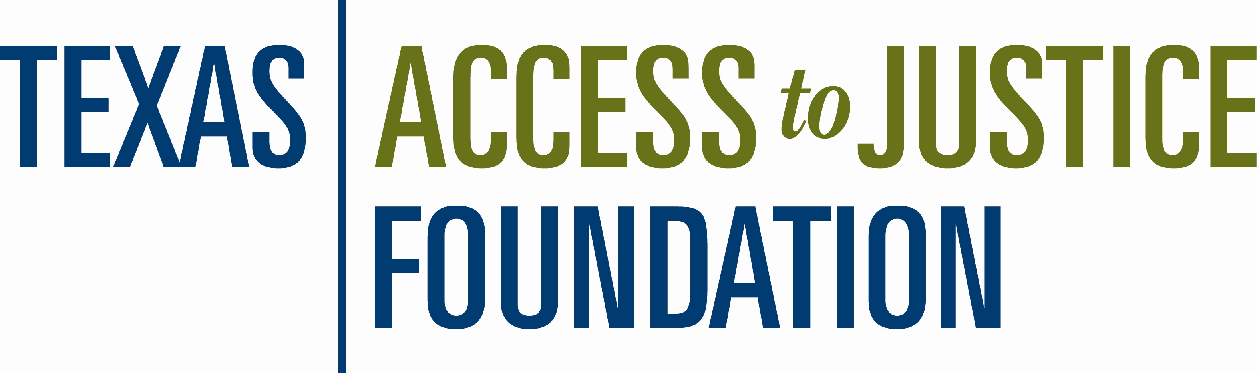

FOR IMMEDIATE RELEASE
November 7, 2008
Contact: Meg Meo, Elizabeth Christian & Associates Public Relations
512-494-2867 or mmeo@echristianpr.com

Lone Star National Bank Becomes a Prime Partner

“The Valley’s Bank” Partners with the Texas Access to Justice Foundation to Help Boost Funding for Legal Aid in Texas

AUSTIN, Texas  Lone Star National Bank, with locations across the Rio Grande Valley, is the latest participant in the state’s Interest on Lawyers’ Trust Accounts (IOLTA) program to become a Prime Partner—institutions that choose to go above and beyond and pay a net yield of 70 percent or more of the Federal Funds Target Rate.

The Texas Access to Justice Foundation receives a significant amount of its funding from IOLTA accounts and uses this money for grants to legal aid service providers across Texas, including Texas RioGrande Legal Aid, Proyecto Libertad and ProBar, which provide services in the Rio Grande Valley. Prime Partner banks, which pay interest at higher rates than other participating banks, have a direct, positive impact on the amount of money available to help low-income Texans with their civil legal issues.

“Legal Aid programs are severely under-funded and unable to meet the overwhelming demand for legal services,” Betty Balli Torres, executive director of the Foundation, said. “Prime Partner banks, such as Lone Star National Bank, are to be commended for their efforts in aiding those who desperately need assistance for a wide range of legal issues, including domestic abuse, landlord-tenant disputes, life-sustaining service denials and other civil matters.”

-More-

Page 2

"Lone Star National Bank is committed to supporting legal aid in the Rio Grande Valley," Geraldo Perez, senior vice president of Lone Star National Bank, said. "Locally, the ratio of eligible clients to legal aid attorneys is 25,000 to 1. Joining the Prime Partner Program is an excellent opportunity to get additional funding into the hands of those that serve."

The Texas Access to Justice Foundation’s 2008 IOLTA revenue was projected to be $28.0 million, but based on recent interest rate cuts, it is now projected to be $12.5 million. Given the current economic crisis, additional interest rate cuts are likely to further impact legal aid funds in Texas. Prime Partners, such as Lone Star National Bank, help to mitigate the decline in revenue available to fund legal aid.
-30-

The Texas Access to Justice Foundation (www.teajf.org), created by the Supreme Court of Texas in 1984, is the leading state-based funding source for the provision of civil legal aid in Texas. The organization is committed to the vision that all Texans will have equal access to justice, regardless of their income. The Foundation administers a variety of funding sources, which are earmarked to assist nonprofit organizations in providing legal aid to approximately 100,000 Texans each year.

