

FOR IMMEDIATE RELEASE
January 23, 2009
Contact: Kimberly Schmitt
512-320-0099 x 104 or kschmitt@teajf.org

American Academy of Matrimonial Lawyers Foundation Supports Work of Lawyers on FLDS Case

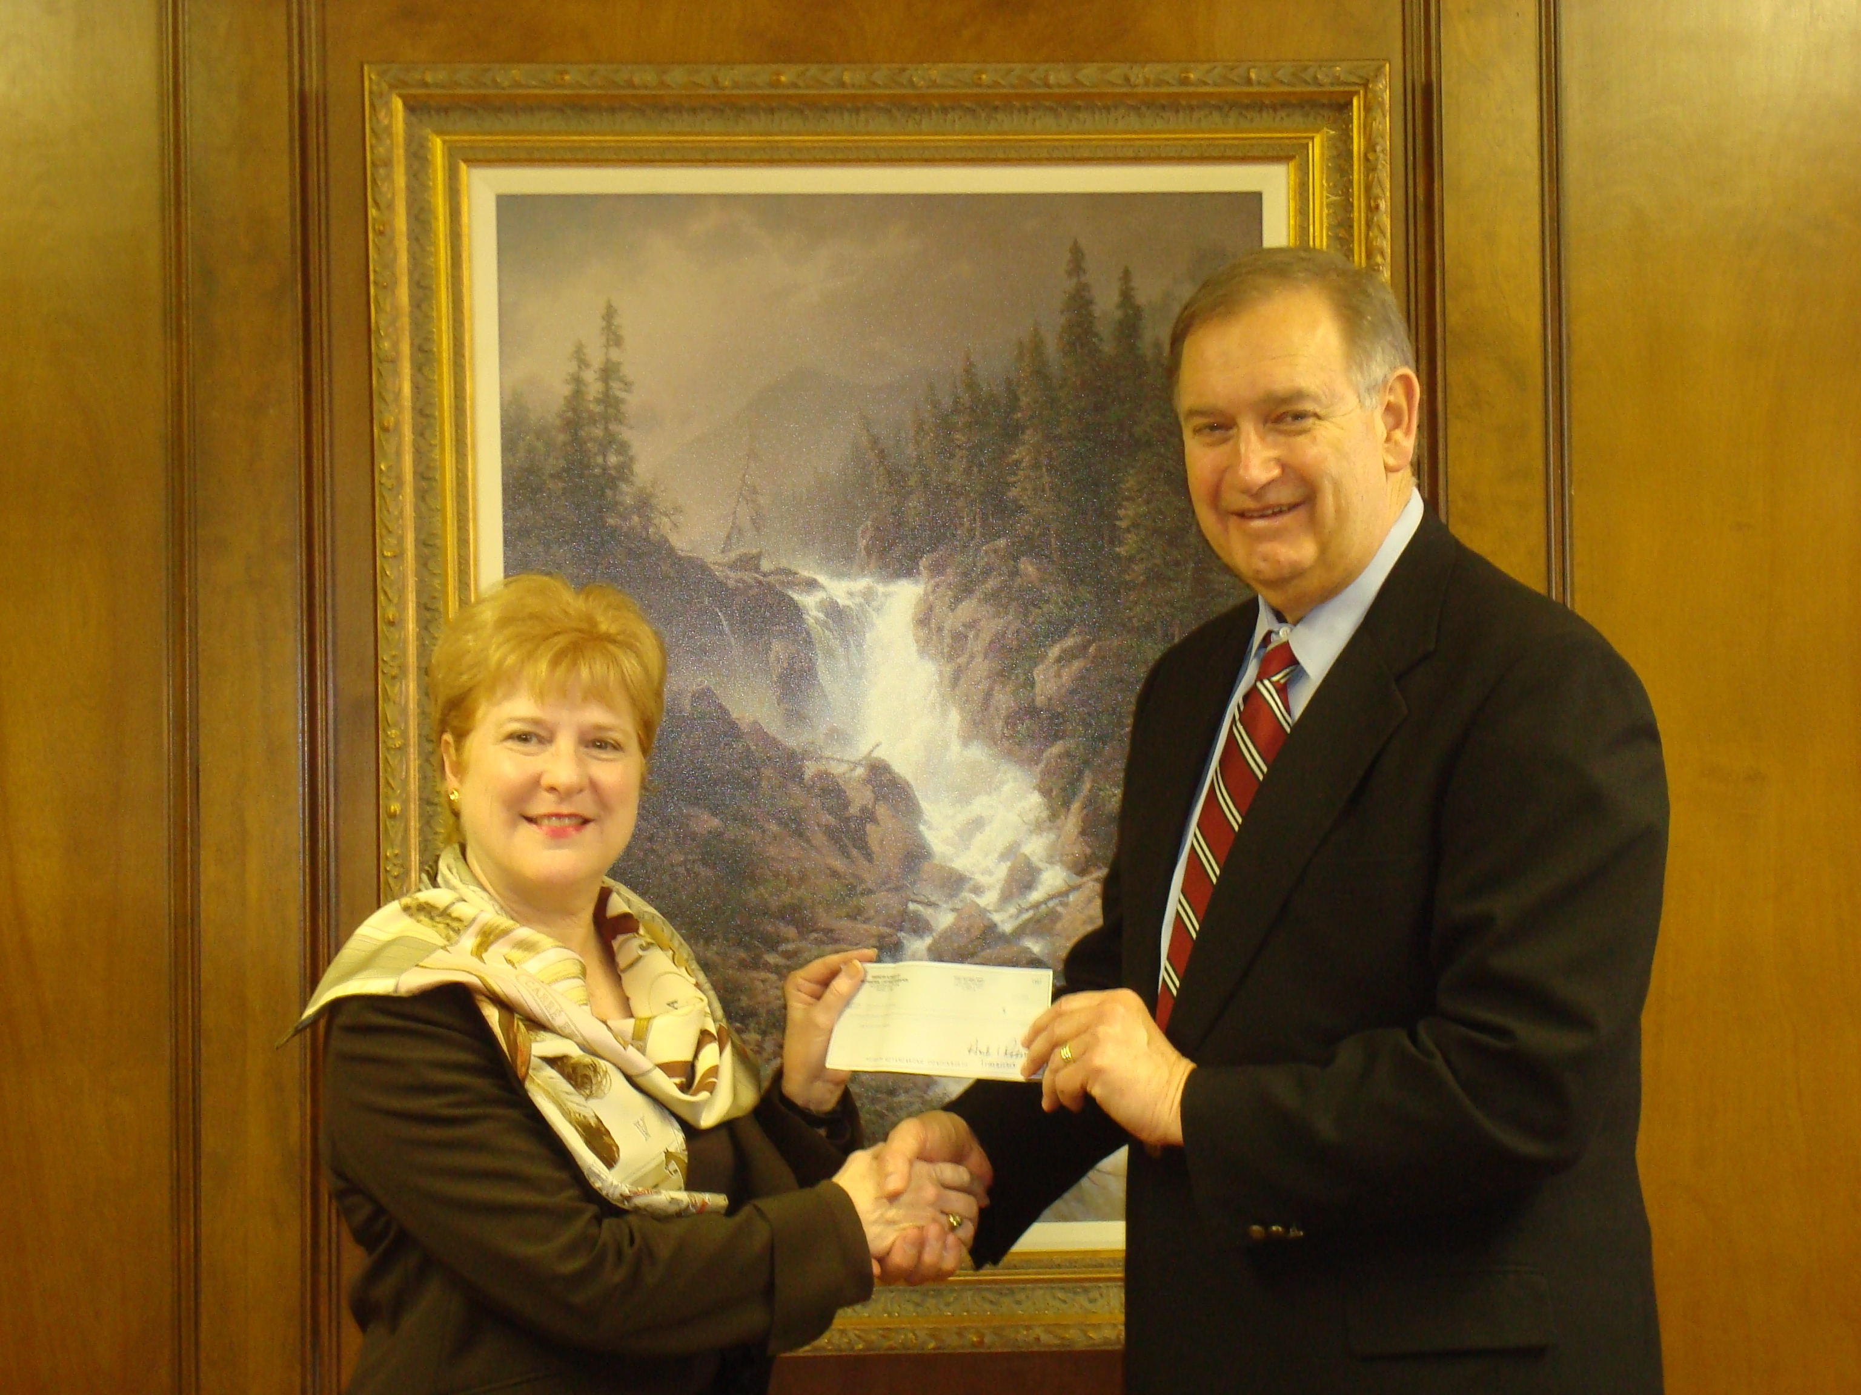
Barbara Runge, Board Member of the American Academy of Matrimonial Lawyers Foundation presents a $2,500 check to Richard L. Tate, Chair of the Texas Access to Justice Foundation. This grant will help support the lawyers who worked on the Fundamentalist Church of Latter-day Saints (FLDS) lawsuits in Eldorado, Texas, in 2008. TAJF helped reimburse volunteer attorneys who provided pro bono civil legal assistance for administrative costs, such as travel and lodging.
-30-
The Texas Access to Justice Foundation (www.teajf.org), created by the Supreme Court of Texas in 1984, is the primary state-based funding source for the provision of civil legal aid in Texas. The organization is committed to the vision that all Texans will have equal access to justice, regardless of their income. The Foundation administers a variety of funding sources, which are earmarked to assist nonprofit organizations in providing legal aid to approximately 100,000 Texans each year.

