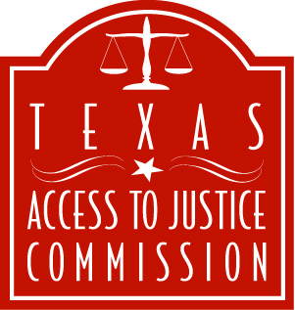

FOR IMMEDIATE RELEASE
May 22, 2007

Contact: Laura Figueroa
512.320.0099, ext.104 (office)
512.659.4750 (mobile)

TEXAS ACCESS TO JUSTICE COMMISSION HOSTS EVIDENCE ACADEMY FOR
LEGAL AID LAWYERS

AUSTIN, Texas --- The Texas Access to Justice Commission hosted the Evidence Academy in Austin May 17-18, 2007, for legal aid attorneys. The Evidence Academy, held at The University of Texas Law School, gave legal aid attorneys the opportunity to enhance their skills and knowledge regarding the rules of evidence, as well as techniques and strategies for presenting evidence in court.

Members of the elite American College of Trial Lawyers donated their time to share their extensive trial knowledge and skills with the front-line lawyers who advocate for the poor. Membership in the American College of Trial Lawyers is by invitation only, extended to experienced trial lawyers who have demonstrated exceptional skill and whose careers have been marked by the highest standards of ethics and professionalism.

Sixty staff attorneys from legal aid organizations throughout Texas attended the two-day, interactive seminar, which included lectures, mock court proceedings, and Q& A sessions. Evidence Academy faculty demonstrated trial skills through mock hearing, and answered questions from participants about style and technique.

“We are extremely grateful to the Texas Fellows of the American College of Trial Lawyers, along with several outstanding judges and law faculty, for donating their time and extraordinary talents to improve the trial skills of legal aid attorneys who work every day to help the most disadvantaged members of our communities,” said Jim Sales, chair of the Texas Access to Justice Commission.

Dan Bishop of Bishop London Brophy & Doods, P.C. in Austin served as the course director for the Evidence Academy. Academy trainers included:

Steve Goode, University of Texas Law School, Austin
Terry Tottenham, Fulbright & Jaworski, Austin
Steve McConnico, Scott Douglass & McConnico, Austin
Dicky Grigg, Spivey & Grigg L.L.P., Austin
Lynn Liberato, Haynes and Boone, LLP, Houston
David Berg, Berg & Androphy, Houston
Judge Darlene Byrne, 126th District Court, Austin
Judge Suzanne Covington, 201st District Court, Austin
Judge Jennifer Elrod, Harris County Civil Courthouse, Houston
Larry Boyd, Fisher Boyd Brown Boudreaux & Huguenard, Houston

The Texas Access to Justice Commission (www.TexasATJ.org) was created in 2001 by the Supreme Court of Texas to develop and implement policy initiatives designed to expand access to and enhance the quality of justice in civil legal matters for low-income Texans. The Commission has created several initiatives to increase resources for and awareness of legal aid, including the domestic violence Protective Order Kit, the Texas Student Loan Repayment Assistance Program, and www.TexasLawHelp.org, an online resource for free legal information.
-30-

