Resolution On LSC Funding

WHEREAS, the Houston Bar Association, composed of 11,500 members, is committed to the principles that our nation promises justice for all, not just for those who can afford to pay for it, and that equal justice and the fair administration of justice are cornerstones of our democracy and core functions of our national and state governments;

WHEREAS, the Legal Services Corporation is the largest single provider of funding to civil legal assistance programs for low-income Americans, and Texas receives almost $32 million in LSC funding for the legal needs of disadvantaged Texans;

WHEREAS, the three LSC-funded programs in Texas – Legal Aid of NorthWest Texas, Lone Star Legal Aid, and Texas RioGrande Legal Aid – close more than 67,000 cases annually; assisting veterans returning from war, domestic violence victims, individuals undergoing foreclosure or other housing issues, those coping with after-effects of natural disasters, and families involved in child custody disputes;

WHEREAS, the Legal Services Corporation needs full funding to provide Texas grantees with adequate resources to serve the approximately 5.7 million Texans who qualify for legal aid;

WHEREAS, budget for fiscal year 2011 reduced funding for Texas grantees by more than $1.3 million; and the proposed House Appropriations bill for fiscal year 2012 would result in an additional loss of $8.4 million for Texans at a time when the state can ill afford it;

WHEREAS, other sources of legal aid funding are also diminishing, including historically low interest rates which have dramatically reduced funding for the Interest on Lawyers’ Trust Accounts (IOLTA) program from $20.1 million in 2007 to $5.5 million in 2009, creating a 73 percent loss in IOLTA funding for civil legal services since 2007;

WHEREAS, due to lack of resources, only an estimated 20 to 25 percent of the civil legal needs of low-income and poor Texans are being met;

WHEREAS, the Supreme Court of Texas is a leader in access to justice issues in the nation and with tremendous bipartisan support in the 2011 Texas Legislature, secured $17.5 million for civil legal aid for the biennium;

THEREFORE, BE IT RESOLVED that the Houston Bar Association respectfully requests that Congress adequately fund LSC in your fiscal year appropriations bill and ensure that funding to the program is not reduced. We encourage you to adopt the Administration’s request of $450 million, but at a minimum, LSC should receive no less than its current funding of $404.2 million.

SIGNED this 12th day of September, 2011

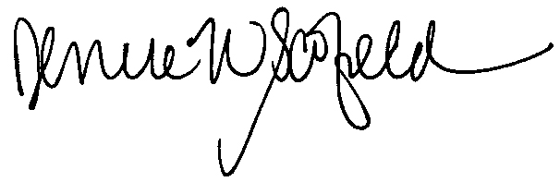
Denise Scofield
President, Houston Bar Association

