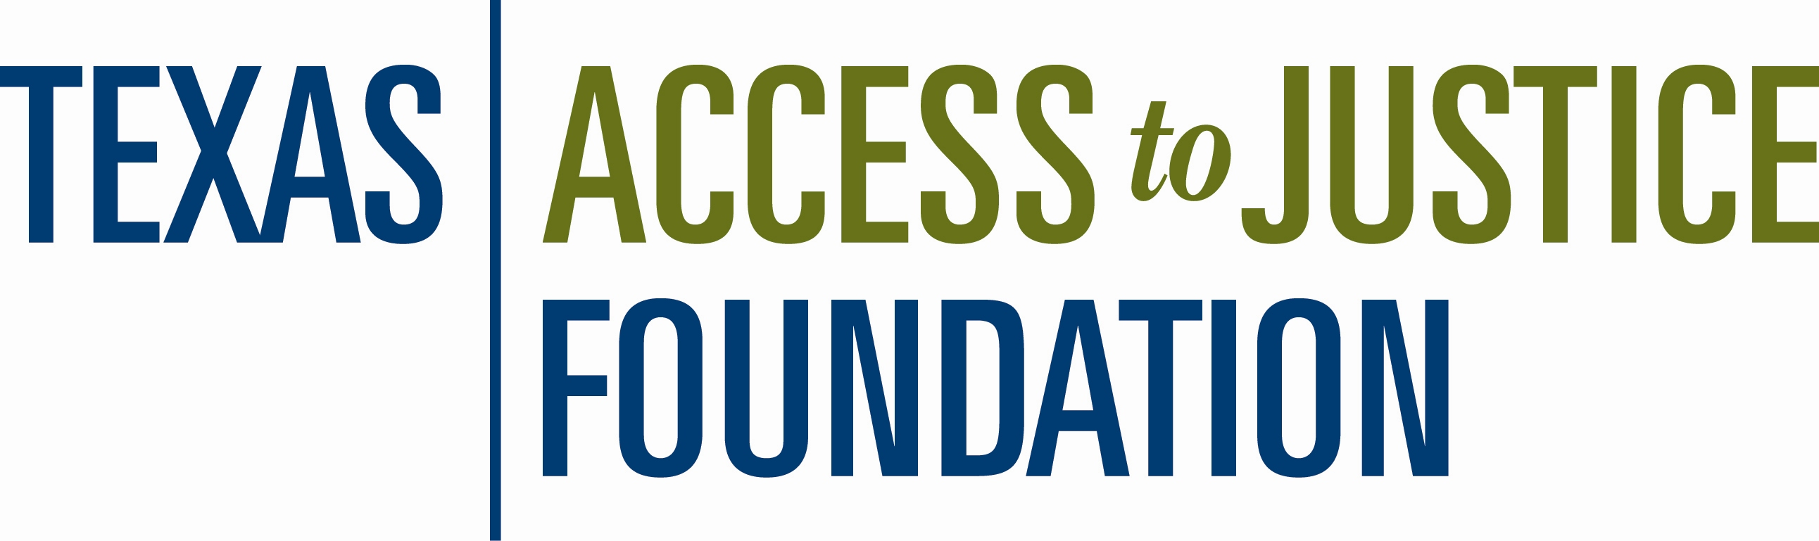

“I Bank on Justice” Campaign Authorization

I authorize my photo and information to be used by the Texas Access to Justice Foundation in conjunction with the promotion of the Prime Partner Bank Program.

___________________________________________

Signature

____________________________________________________

Printed Name

____________________________________________________

Firm Name

____________________________________________________

Prime Partner Bank Name, Location

My photo is attached in a .jpg, gif, or png. format

Return this authorization and send photo to: kschmitt@teajf.org

Sample use of information:
